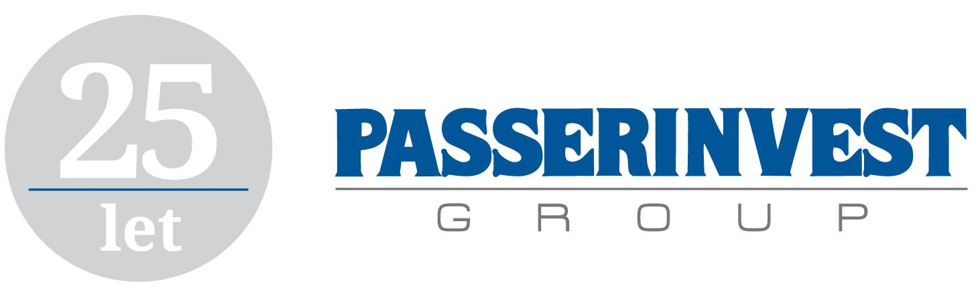

**PRESS RELEASE** Prague, 11th May 2017

**Radim Passer achieves prestigious CEEQA 2016 award**

**Radim Passer, the founder and CEO and Chairman of the Board of the development and investment company PASSERINVEST GROUP, has received one of the most prestigious awards that can be had in the entire Central and Eastern Europe region, the Central & Eastern European Real Estate Quality Award (CEEQA) for Lifetime Achievement in Real Estate. The award is granted each year to a personality that has a transformational and constant influence and contribution for the property sector of the “new” Europe.**

Radim Passer, who is primarily connected with the construction of the innovative multifunctional BB Centrum complex in Prague 4, accepted the award on 26 April in Warsaw as part of the awards ceremony together with the other award winners.

Each year the CEEQA awards are organised by the CEE Insight Forum in cooperation with the prestigious Financial Times newspaper, which choose the best personalities, companies and projects across 18 Central and Eastern European countries. The members of the jury are bankers, consultants, investors and other experts from the area of Real Estate. The awards ceremony in Warsaw is the largest event of its kind in Central Europe. Only this lifetime achievement award is known and announced in advance and its presentation is the highlight of the entire evening.

The independent professional jury primarily appreciated the construction and further development of the multifunctional BB Centrum complex as a “city within a city” and they consider Radim Passer to be one of the most active pioneers in the reconstruction of Central and Eastern Europe after the fall of communism.

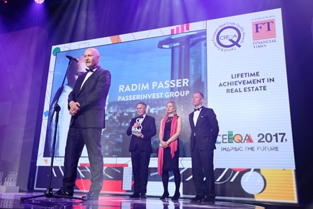

From the left: Radim Passer, CEO and Chairman of the Board PASSERINVEST GROUP, a.s., Richard Hallward, Managing Director, IMAGINE LIVE MEDIA, Judith Evans, Property Correspondent, Financial Times, a Jonathan Hallett, Managing Partner Central & Eastern Europe, Cushman & Wakefield

For more information and photographs in print quality please contact:

Kristýna Samková**,** Head of PR and Marketing dept.

**PASSERINVEST GROUP, a.s.**

Tel.: (+420) 221 582 111

Mobil: (+420) 602 186 708

E-mail: [Kristyna.Samkova@Passerinvest.cz](mailto:Kristyna.Samkova@Passerinvest.cz)

www.passerinvest.cz, [www.bbcentrum.cz](http://www.bbcentrum.cz)

Marcela Štefcová

**Crest Communications a.s.**

Mobil: (+420) 731 613 669

E-mail: marcela.stefcova@crestcom.cz

**About the Developer**

**PASSERINVEST GROUP, a.s.,** founded in 1991 by Radim Passer, is a purely Czech development and investment company whose name is associated in particular with the **BB Centrum** multifunctional complex in Prague 4 - Michle. With this project, the most successful and extensive Czech project of its type, the company has built its excellent reputation both at home and at the international level. Contributing to this is not only the high quality of the projects completed to date, but also its high level of service, its sense of fair play, its positive relationship with the tenants and users of its buildings, and its sense of responsibility towards society and the environment. **PASSERINVEST GROUP**’sportfolioincludes other interesting development projects.